University Institute of Information Technology

PMAS-Arid Agriculture University, Rawalpindi



Project Proposal

For

**Online Assessment Portal**

**Submitted By:**

Kashif Lateef

18-ARID-2490

Muhammad Zeeshan Khan

18-ARID-2540

Ehtesham Safeer

18-ARID-2460

**Supervised By:**

Ms.Sidra Tahir

Revised Version

Project ID:___________

(ID will be assigned by coordinator)

* **Please select the appropriate category of your project***(Select multiple if required)*

**A-**Desktop Application/Information System **🞏B-**Problem Solving and AI**🞏**

**C-**Web Application/Web Application based Information System. **🗹D-**Simulation&Modeling **🞏**

**E-**Smartphone Application **🞏 F-**SmartphoneGame **🞏**

**G-**Image Processing **🞏** **H-**Networks **🞏**

**I-** Other: ____________________________________ **🞏**

**Group Members:**

Muhammad zeeshan khan

18-ARID-2540

[zeeshanafridi8413@gmail.com](mailto:zeeshanafridi8413@gmail.com)

BSCS 7th A Morning

Ehtesham Safeer

18-Arid-2460

[ehteshamrajpoot01@gmail.com](mailto:ehteshamrajpoot01@gmail.com)

BSCS 7th A Morning

Kashif Lateef

18-arid-2490

[qazikashif745@gmail.com](mailto:qazikashif745@gmail.com)

BSCS 7th A Morning

table of contents

1. Introduction 4

2. Literature Review 4

3. Problem Statement 4

4. Problem Solution 4

5. Advantages/Benefits of proposed system 4

6. Scope 4

7. Software Methodology 5

8. Tools and Technologies 5

9. Concepts 5

10. Intended Users 5

11. Mockups 6

12. Conclusion 6

## Introduction

This project provide an online plateform of learning System.

It provides a virtual classroom where teacher and students connect with eachother and to solve any problem. Teacher can upload assignment and take quizes from students. Quiz will be skilled base and it gives a plateform to teacher in which teacher can check plagiarism of assignment. This plateform also provides advance courses for students, which students can enroll to their interest where they learn about new technology. Which includes assignments,quizes and competition between student. At the end of course Admin can do live quiz competition for students and winner will be given prizes or discount for other courses.

## Literature Review

## Myrank.com

* Google classroom

Above mention websites are related to my project.They all are functioning good.But the main thing which is missing in these three systems is that to take quiz and make competition between students.Students do not take intereset in online learning but for winning the competition they will take interest to compete eachother. Moreover live quiz system and competition system is also feature of my project,that will be notified.

## Problem Statement

## After visiting many e-learning plateforms we realized that many e-learning plateform provides a lot of advance courses and content for these course but not proper tutor for that courses who properly guide students. They give lectures and data but not a proper guidline from which students can get guideness and they also don’t make any competition between students that can increase interest in students for that course.

## Problem Solution

## For the solution of above stated problems,we are going to propose to develop a online assessment portal in which we offer advance courses and virtual classroom where a tutor will share lectures,quiz ,assignment and make competition between students. Quiz will be skilled base. The result of quiz tells the percentage of each course. And give plateform to teacher that can also check the palagarism of assignment. At the end of courses a competition organized on website and the winner receive prize or discount from other courses.There are so many e-learning websites. But the main purpose to reimplement the same system to add extra feature.

## Advantages/Benefits of proposed system

* Online learning accomodates everyone’s needs
* Lectures can be taken any number of times
* Offers acess to updated content
* Quick delivery of lessons
* Less impact on environment

## Scope

E-learning can be applied in two major ways: Presenting education content and facilitating education processes. E-learning tools can operate effectively within both carefully selected and optimally integrated course design model and as emergent facilitators of communication and learning in informal contexts.

Admin can login using credentials and manage the whole website. Teacher and student register to create account and login to create virtual classroom to connect with eachother. Admin offers other advance courses. Interesting student can enroll about their interest and manage the request raised by student by approving or rejecting it. Admin select a teacher for the course in which student enroll.

Admin can show details of students and teachers. And also manage quiz system at the end of course.

**Modules of the project:**

* Admin
* Teachers
* Students

**Explanation of a Module:**

**Admin**

* Admin can login the System.
* Admin can manage all the profiles of teachers and students.
* Admin can manage the setting of website.
* Admin can set a competition between students at the end of course.

**Teachers**

* + Teachers can register/login into the system.
  + Teachers can create a virtual classroom.
  + Teacher can add and remove students.
  + Teachers can upload assignments and take quizes.
  + Teachers chat with students if they have any problem.

**Students**

* + - Student can register and login into the system
    - Student can join virtual classroom by given link from teacher.
    - Student can view and uploaded assignments and solve quizes
    - Student can also select advance extra courses which admin offers.
    - Student can enroll advance course

**Teacher**

**Students**

**Data Base**

**Architectural Diagram**

**Architectural Diagram**

## Software Methodology

This project is based on waterfall methodology.The reason behind is that we need to perform all of the task which are related to our project in a sequence though a series of phases.The waterfall model is a sequential, design process used in software process in which progress is seen as a flowing steadily downwards through different phases.

## Tools and Technologies

* Html,css bootstrape
* Javascript
* Php laravel
* MYSQL database
* Visual Studio Code
* xampp

## Concepts

**Web Development:**

Front End: How to development a good interface for a website.

Backend: How to to create a data base for a website.

And how to connect front end with back end

## Intended Users

Teachers and student are intended user of this system.

**Teacher**

They will register and login to create classroom and add students

**Student**

They will also register and login and join class and select other advacne courses

## Mockups

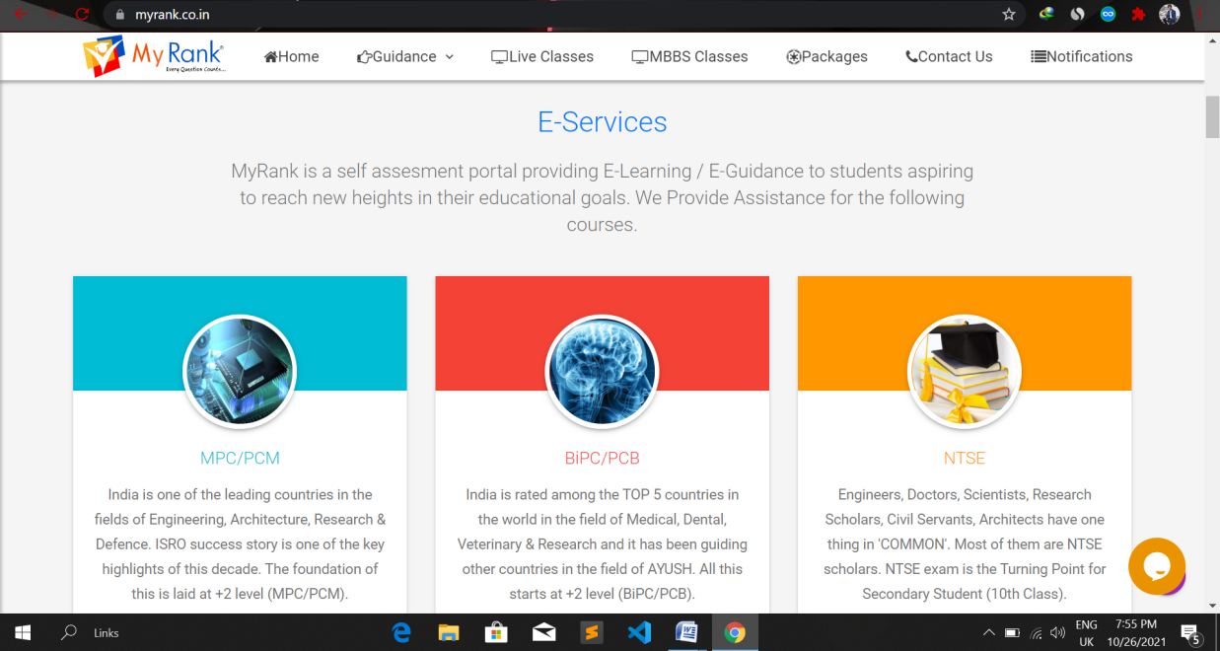

**Figure 1**

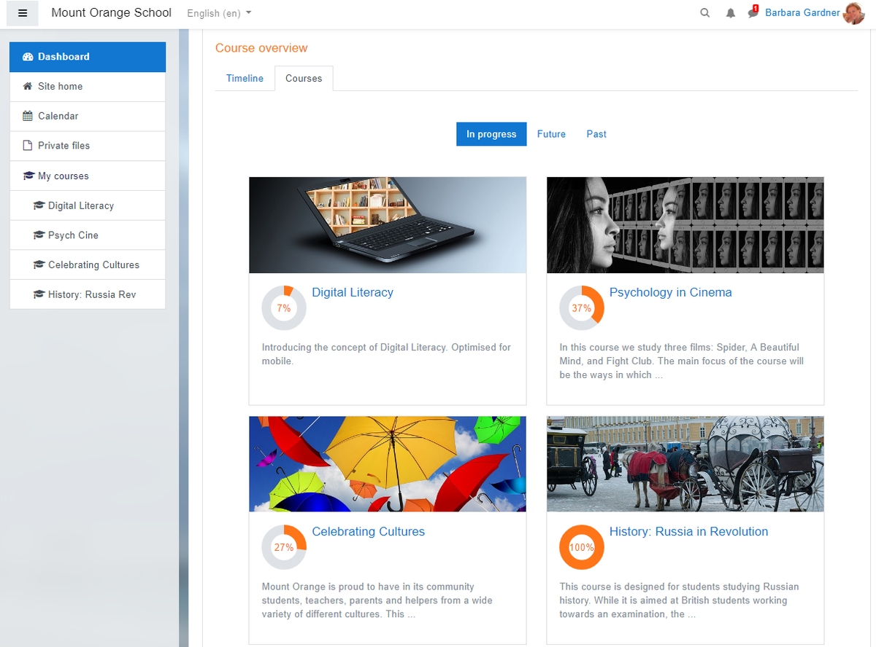

**Figure 2**

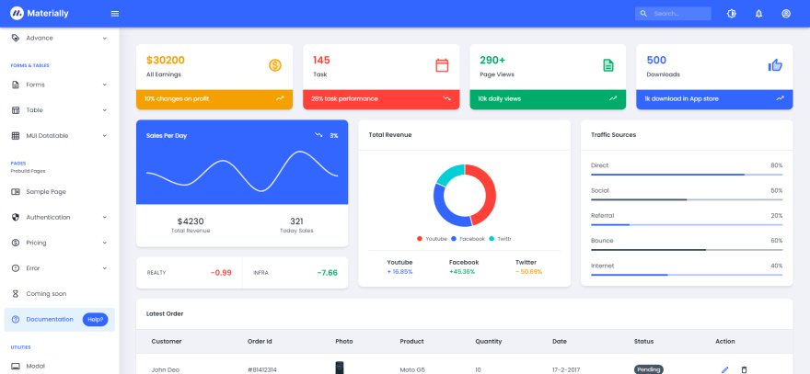

**Figure 3**

## Timeline

**Figure 4**

## Conclusion

In today’s world of covid-19, so many student around the world faces difficulties during online learning. They can not learn porperly and have not taken interset.This learning system is very necessary in this situation. Hope that our developed system will be helpful.

## Reference

1. <https://myrank.co.in/>
2. <https://classroom.google.com/h>

**Evaluation Page**

**Evaluator 1 Comments:**____________________________________________________________

_________________________________________________________________________________

_________________________________________________________________________________

_________________________________________________________________________________

_________________________________________________________________________________

_________________________________________________________________________________

_____________

Signatures

**Evaluator 2 Comments:**____________________________________________________________

_________________________________________________________________________________

_________________________________________________________________________________

_________________________________________________________________________________

_________________________________________________________________________________

_________________________________________________________________________________

_____________

Signatures

**Project Coordinator Comments**_____________________________________________________

_________________________________________________________________________________

_________________________________________________________________________________

_________________________________________________________________________________

_________________________________________________________________________________

_________________________________________________________________________________

_________________________________________________________________________________

_____________

Signatures